Summer Exam A

5TH Year Business

2 hour exam

Each student must answer Q1

Students can then choose 3 from 4 questions from Q2->Q5

Q1 – 75 marks (40 mins)

Q2 -> Q5 – 60 marks each (25-28 mins each)

Marks
Q1 | Q2 | Q3 | Q4 | Q5 | TOTAL
/75 | /60 | /60 | /60 | /60 | /255

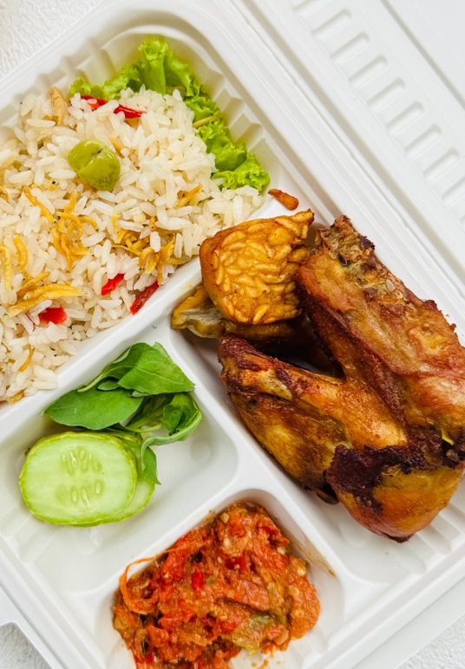
Grainne's Kitchen
Grainne Walsh founded Grainne's Kitchen in 2023 after studying food science at MTU and spotting a gap in the market for healthy, portion-controlled meals delivered to busy professionals and fitness enthusiasts. She used her own savings and a start-up grant from her Local Enterprise Office to launch the business, initially preparing meals in a rented commercial kitchen and delivering them herself. Early challenges included sourcing reliable packaging suppliers and building a customer base with a limited marketing budget.

Today, Grainne's Kitchen employs 12 people, including kitchen staff, delivery drivers, and a part-time social media manager. The business sells directly to customers through its website and app, offering weekly subscription plans. Grainne recently hired a business manager, Ciarán, to handle the day-to-day running of the kitchen operation. Ciarán is responsible for scheduling shifts, managing supplier orders, and ensuring meals go out on time. This has freed Grainne to focus on growing the brand and planning the next stage of the business with new partners. Grainne often reflects that her strength lies in spotting opportunities and driving the business forward, while Ciarán keeps the operation running smoothly behind the scenes.

The company has built a strong brand through Instagram, where recipe videos and behind-the-scenes content have attracted over 30,000 followers. Grainne has also partnered with two local gyms to cross-promote her meals to their members. Despite this success, Grainne has noticed that staff are not always clear on their daily targets or kept up to date on menu changes. She recognises that choosing the right way to communicate, whether a team briefing, a message, or a face-to-face conversation, has become more important as the team has grown.

Grainne is now preparing to expand into a second city. She has drafted job advertisements for additional kitchen staff and delivery drivers and has set aside time in her weekly schedule for interviews. Some staff have expressed concern about the impact the expansion could have on their roles and workload. A number of new meal-prep competitors have also entered the Cork market in recent months, offering lower prices. To fund the expansion, Grainne is preparing a business plan to present to potential investors.

(a) (i) Identify three competencies of an entrepreneur shown by Grainne Walsh. (6 marks)
1.
2.
3.

(a) (ii) Grainne’s Kitchen has both a leader and a manager. Outline two differences between them under the following headings: (10 marks)
1. Role in Business
2. Risk and Innovation

(b) Grainne is recruiting new staff for the expansion. Outline the three stages of the recruitment process she should follow. (12 marks)
1.
2.
3.

(c) Explain two ways, apart from listening actively, that Grainne could improve communication in her business. (12 marks)
1.
2.
(d) Some staff have expressed concerns about the planned expansion. Explain two reasons why employees in Grainne’s Kitchen may resist this change. (10 marks)
1.
2.

(e) (i) Conduct a force-field analysis to examine the potential effects of Grainne’s decision to expand into a second city. (20 marks)
Driving Force 1:
Driving Force 2:
Restraining Force 1:
Restraining Force 2:
Overall Finding for Grainne (State which force is stronger and why):

(e) (ii) Explain the importance of planning for change for a business like Grainne’s Kitchen. (5 marks)

Extra answer space for Q1.

Question 2 (60 marks)
The Smooth Company was founded by Áine Kennedy, a Dublin entrepreneur who spotted a gap in the market while scrolling TikTok during lockdown in 2020. She noticed people using makeshift products to tame flyaways and baby hairs, and spent two years developing a solution. In 2022, she invested her savings into launching the SmoothStick, a premium hair-taming wand, from her attic - with her grandfather Billy helping to pack the orders.
Áine built the business entirely through organic social media content, posting TikTok videos without any paid advertising. The brand has amassed over 150 million views on the platform, which drove direct sales through its website. Half of all sales come from overseas, with the US and UK as key markets. The Smooth Company is predominantly an ecommerce business but has recently expanded into retail, securing listings with stockists in Ireland, the UK, and Europe.

(a) Outline two factors that can impact on the development of business ideas for businesses like The Smooth Company. (10 marks)
1.
2.
(b) (i) Name the four stages of design thinking.
(ii) Outline how this process is both iterative and person-centred, using The Smooth Company as an example of how each could apply. (10 marks)
(i) 1.
2.
3.
4.
(ii) Iterative:
Person-centred:
(c) Explain an impact of digital technology on both market research and marketing. Refer to The Smooth Company in your answer. (12 marks)
Market Research:
Marketing:

(d) Outline two stakeholders of The Smooth Company and explain their importance to the business. (10 marks)
1.
2.

(e) Analyse three ways organisational culture can contribute to the success of a growing business. (18 marks)
1.
2.
3.

Question 3 (60 marks)
(a) Fill in the missing term in each of the following statements. (10 marks)
1. The four risk management strategies are avoidance, spread, prevention and I_______________.

2. The nine building blocks used to map a business model onto one page is called the Business Model C_______________.

3. A S_______________ is a recurring payment made by customers for ongoing access to a product or service.

4. A study carried out to assess whether a business idea is viable before launch is called a F_______________ study.

5. A business’s Value P_______________ outlines what makes consumers choose that good or service over others.

Gym+Coffee is an Irish athleisure brand targeting young, active consumers who value comfort, community, and sustainability.
(b) Outline three elements of the marketing mix and explain how they might be influenced by Gym+Coffee’s target market. (15 marks)
1.
2.
3.
Flahavan's is a seventh-generation family business based in Kilmacthomas, Co. Waterford, milling oats on the same site since 1785. The company works closely with local oat farmers within 60 miles of the mill, who supply the raw materials for its range of porridge oats, granola, and oat drinks. Flahavan's sells its products through major supermarket chains across Ireland and to retail partners in over 20 countries, making export sales an increasingly important part of the business. The company has built a loyal following of health-conscious consumers who value its Irish heritage and natural ingredients, and it engages with customers directly through social media and its website. Flahavan's is a founding member of Origin Green, Ireland's national food sustainability programme. Running a milling operation means the business carries significant costs on its premises, including energy, equipment maintenance, and the wages of its workforce, alongside costs such as oat purchasing and packaging.

(c) Identify three of the following elements of the business model canvas for Flahavan’s. (10 marks)
Value Proposition | Customer Segments | Channels
Revenue Streams | Cost Structure | Customer Relationships

1.
2.
3.
(d) Describe three factors that impact on employee motivation in a workplace. (15 marks)
1.
2.
3.

(e) Outline two ways stakeholders in a business may interact and, for each, identify a potential conflict that could arise. (10 marks)
Interaction between business owners and employees:
Potential conflict:
Interaction between business and the local community:
Potential conflict:

Question 4 (60 marks)

(a) Indicate whether each of the following statements is true or false by putting a tick (✓) in the correct box. (10 marks)

Statement | True | False
1. A democratic leader makes all decisions without consulting employees.
2. Innovation allows a business to create a competitive advantage in the market.
3. An Applicant Tracking System (ATS) can be used to making the recruitment process more efficient for a business.
4. Greenwashing is when a business genuinely commits to sustainable practices.
5. Ethics in marketing includes being honest and transparent in advertising.

(b) Explain the importance of innovation for both business and the economy. (10 marks)
For Business:
For the Economy:

All Real Nutrition is a Kerry-based business that produces protein bars using natural ingredients. Founded in 2017, the company began by making bars in a kitchen and selling them at local farmers' markets. It has since moved to a factory in Farranfore and grown to sell across Ireland and to export markets in the UK.

(c) (i) Outline the elements of the operational model for a business and explain why these may change as a business like All Real Nutrition grows. (15 marks)
1.
2.
3.

(c) (ii) All Real Nutrition currently earns revenue through single transactions in retail stores. Suggest one other revenue stream it could use and how it would benefit All Real Nutrition. (5 marks)

Sculpted by Aimee is an Irish makeup brand founded by Aimee Connolly. The company is committed to cruelty-free testing and sustainable packaging.

(d) Evaluate the influence of ethics and sustainability on marketing for a business like Sculpted by Aimee. (20 marks)

Question 5 (60 marks)
(a) Match each approach to appraisal in Column A to its correct description in Column B. (10 marks)

Column A | Column B
1. Self-appraisal | A. Feedback is gathered from managers, colleagues, and others to give a full picture of performance
2. Formative appraisal | B. A formal review of overall performance carried out at the end of a set period
3. Summative appraisal | C. The employee reflects on and evaluates their own performance against agreed targets
4. 360-degree appraisal | D. An ongoing, informal process where a manager gives continuous feedback during day-to-day work

Fill the correct letter from Column B underneath the type of appraisal from Column A

1 | 2 | 3 | 4

(b) (i) Explain what is meant by contingency planning in terms of crisis management. (5 marks)

(b) (ii) Outline two factors that should be considered when developing a contingency plan. (10 marks)
1.
2.

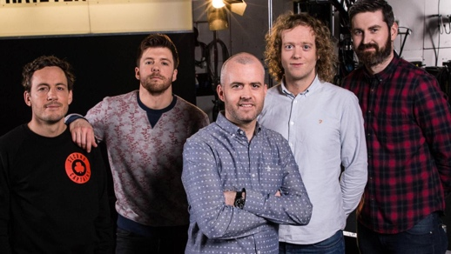
Second Captains is an Irish sports media company producing daily podcasts. A limited number of weekly podcasts are available for free each week with ads, while members can pay €5 a month for access to daily ad-free podcasts. The podcast launched its paid subscription service in February 2017 and within the first day had attracted 2,500 subscribers.
The Second Captains team originally produced and presented the Off The Ball show on Newstalk radio for eight years, winning nine PPI national radio awards.

(c) Identify the business model used by Second Captains. Choose another common business model and compare them under the headings ‘revenue generation’ and ‘how they deliver value to the customer’. (10 marks)
Second Captains Business Model:
Business Model 2:
Revenue Generation:
How they deliver value:

McDonald's is one of the world's largest fast food chains, operating over 40,000 restaurants across more than 100 countries, including over 100 locations in Ireland. The business operates primarily through a franchise model, where individual owners run restaurants under the McDonald's brand and system. McDonald's supplies its franchisees with ingredients, packaging, and equipment through a network of approved suppliers. Customers can order in-store, through self-service kiosks, via the McDonald's app, or through delivery platforms such as Deliveroo and Just Eat. The fast food market in Ireland includes well-established competitors such as Burger King, KFC, and Subway, as well as a growing number of independent burger and chicken restaurants.

(d) Analyse the competitive environment for McDonald's using Porter’s five forces model.
Based on your analysis, identify McDonald's competitive advantage. (25 marks)
1. Rivalry among existing competitors:
2. Threat of new entrants:
3. Bargaining power of buyers:
4. Bargaining power of suppliers:
5. Threat of substitute products:
Competitive Advantage:

Extra answer space – clearly label the Qs that you are adding content to in this space.

