5th Year Business
Christmas Exam

Chapters 1,6,7,8,9,10

2 hours
225 marks

Instructions

There are four questions in this paper.

Question 1 75 marks
Questions 2 to 5 50 marks each

Answer Question 1 and any three other questions.

NAME:
TEACHER:
RESULT:

Q1 Business In Our World
FíorFuel

FíorFuel is an Irish start-up founded by two friends, Maeve and Darragh, who wanted to create a superfood powder made entirely from Irish-grown ingredients. Their aim is to provide a daily health supplement rich in vitamins and minerals — a sustainable, locally sourced alternative to imported “super greens.”

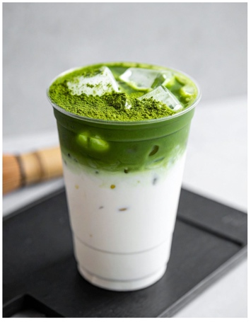
They work closely with Irish farmers who grow kale, spinach, barley grass, and beetroot, which are then dried and blended into powdered sachets. The business also partners with a local packaging supplier that produces recyclable pouches. At first, suppliers required up-front payment, but as trust developed and orders became more consistent, FíorFuel began receiving bulk deliveries on credit terms.

Digital technology plays a major role in how the company operates. FíorFuel uses cloud-based stock-control software to track ingredient deliveries and finished goods, and manages all sales through its e-commerce website. They promote the brand through targeted social-media campaigns on Instagram and TikTok, and use analytics tools to identify which ads drive the most sales. The founders also hold regular Zoom meetings with app developers in Australia, who help manage their online store and develop new subscription features for repeat customers.

Innovation has been key to FíorFuel’s growth. The founders encourage all staff to share product ideas and customer feedback through weekly brainstorming sessions. This culture of openness has helped generate new blends, such as a caffeine-free “morning boost” version. The business also invites health and fitness coaches to trial products and suggest improvements, ensuring continuous development of new ideas.

FíorFuel’s business model centres on providing convenient, Irish-sourced nutrition for health-conscious customers. Daily activities include ingredient sourcing, production, packaging, and online marketing. They work on building trust, education, and transparency about sourcing and nutrition with the customer. Its main customer type are young professionals and fitness enthusiasts, though a growing number of customers in their 40s and 50s have shown interest in the health benefits of Irish-grown supplements. The main costs include raw materials, packaging, technology, digital advertising, and delivery logistics.

Ethics are a cornerstone of the business. FíorFuel commits to fair pricing for farmers, transparent labelling, and responsible health claims that avoid exaggeration. Their marketing focuses on real-world benefits, diversity, and inclusion, ensuring messages appeal to a wide audience without unrealistic expectations. They also promote workplace wellbeing and fair conditions for staff as part of their company values, sharing free Friday videos where staff are free to take time off if they need to.
(a) (i) Outline the importance of suppliers for FíorFuel.
(ii) Explain how the needs/wants of a supplier in a business may change at different stages of business development.

(b) Describe three ways digital transformation has impacted on FíorFuel’s operations.
1.
2.
3.

(c) Determine the factors that have impacted on the development of business ideas in FíorFuel.

(d) Identify the key elements of the business model canvas that are missing for FíorFuel, and complete their business model canvas.

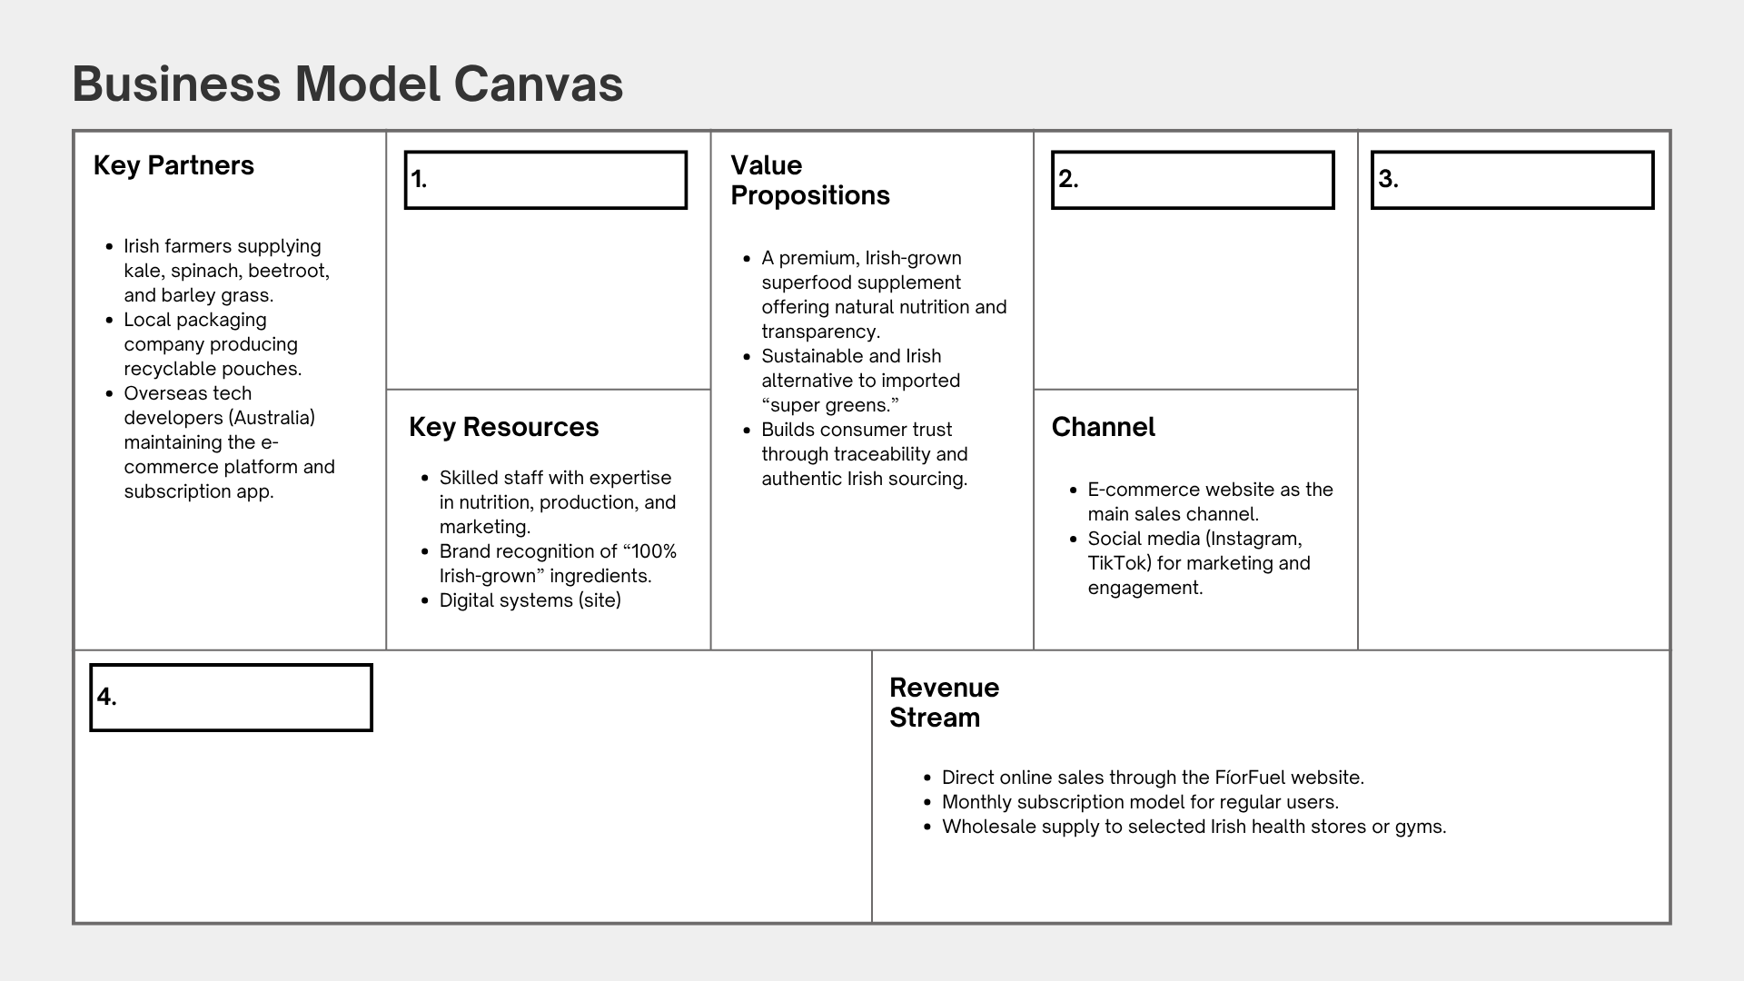
(e) FíorFuel has recently decided to expand its production capacity by leasing a new facility outside Galway to meet growing demand. The move will allow them to increase output and reduce delivery times, but it also means hiring new staff and investing in automated blending equipment.
The expansion will require temporary disruption to current operations while machinery is installed. It will also involve renegotiating supply agreements with local farmers and seeking additional funding from investors to support the move. The company plans to begin production in the new facility within six months.

(i) Conduct stakeholder mapping to identify and prioritise four stakeholders affected by this decision.

(e) (ii) Explain the importance of prioritising different stakeholder interests when making decisions in a business.

Question 2

(a) “A business owner and investor may have different priorities in how the business operates”
(i) Discuss one conflict that might arise between these two stakeholders

(ii) Suggest a way the conflict could be resolved.

(b) (i) Identify three reasons why someone might decide to start their own business.
1.
2.
3.

(b) (ii) Outline the importance of enterprise for the government/economy, society and business.
Government/Economy
Society
Business

(c) Outline the importance of a business plan at both the start-up and operations stage of business development.
Start-up:
Operations:

FuelUp is an Irish protein bar business that started out supplying sports teams and local gyms to try to hit its target market. They soon realised sales volumes were very low thorugh this channel. Its founder then believed that getting stocked in major retail chains such as Spar and Centra was the key to growth and visibility.
After a few years in operation, FuelUp set up their ecommerce shop and discovered that selling directly to consumers through discounted online subscriptions produced far higher profit margins and stronger repeat sales. The company also noticed that casual retail shoppers often buy once or twice but rarely stay loyal to the brand.
FuelUp now wants to analyse which of its customer groups, teams and gyms, retail stores, online subscribers, or casual shoppers, have the most power and interest in influencing the business. The results will guide changes to its marketing mix.

(d) (i) Label and complete the grid below to use a power-interest grid to analyse customer interest for FuelUp.


(d) (ii) Suggest how FuelUp should adjust two elements of their marketing mix, based on your findings.
1.
2.

Nike's business model is built on product innovation, strong brand marketing, and a global supply chain where manufacturing is largely outsourced. The company generates revenue through wholesale, its own retail stores, e-commerce, and licensing, with a focus on creating demand through celebrity endorsements and strategic partnerships. Nike primarily sells footwear and apparel, leveraging both its strong online presence and its physical stores to reach customers globally.

(e) What is the role of a business model in a successful business.

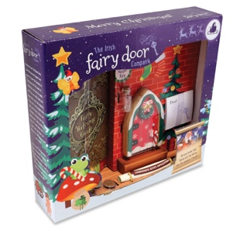
Question 3
Four friends decided to make a go of The Irish Fairy Door Company but soon realised their idea to build a magical world for children behind fairy doors would need more capital than they could provide. The Irish Fairy Door Company reached out for support from their South Dublin Local Enterprise Office, and were able to make their business a success.

(a) Identify three key competencies entrepreneurs would use when setting up a business, and for each one, outline its importance when starting or expanding a business.
1.
2.
3.

(b) Discuss three services The Irish Fairy Door Company would have been able to access from their Local Enterprise Office to support their business development and growth.

1.
2.
3.

(c) Explain three functions of a feasibility study when developing a new business idea for a business like The Irish Fairy Door Company.
1.
2.
3.

(d) (i) Explain three different pricing strategies used by businesses
1.
2.
3.
(ii) Outline two ways the target market for a product or service might influence the packaging / physical evidence element of the marketing mix.
1.
2.
Question 4
(a) Outline, using each stage, how a business of your choice could use the design thinking process to help develop/improve a product or service.
1.
2.
3.
4.

(b) YouTube Advertising Revenue Hits $10.3 Billion as It Takes Growing Share of TV Market

Using any two of the headings below, compare an advertising business model such as the one discussed above with another technology-driven business model you have studied.
1. Revenue generation
2. Consumer access and cost
3. Scalability and growth
4. User engagement and retention
1.
2.

(c) (i) Discuss two ways YouTube could conduct market research
1.
2.

(c) (ii) What is the importance of identifying the target market for YouTube
(d) Outline three ways ethics is an important consideration when designing a marketing strategy.
1.
2.
3.

(e) Managing relationships with different stakeholders is something successful businesses do very well.

Suggest two strategies a business can use to help avoid conflict with stakeholders.
1.
2.

Question 5
Aoife began Luna Scents, a handmade perfume brand she runs from her bedroom.
She buys natural oils and bottles online, mixes small batches, and promotes her perfumes through social media.
Using her laptop, she manages orders, designs labels, and replies to customers who contact her through Instagram and email.
As sales have grown, she has started to consider working with a small local producer and a courier company to handle fulfilment more efficiently, while investing in stronger branding to reach new customers.

(a) (i) Outline any two of the key partners, key activities or key resources that make up Luna Scent’s operational model, and explain why these may change over time.
1.
2.

(ii) Identify a variable and a fixed cost Aoife has incurred running Luna Scents.
1.
2.

(iii) Outline how her variable and fixed costs may evolve over time as her business grows.
Variable Cost
Fixed Cost

(b) Describe how changes in digital technology can impact on both market research and marketing for a new business start-up like Luna Scents.

(c) Examine the cashflow forecast for the Luna Scents and answer the questions that follow.

2026 | JAN | FEB | MAR | APR | TOTAL
RECEIPTS | € | € | € | € | €
E-commerce sales | 22,000 | 24,500 | 26,000 | 27,000 | 99,500
Subscriptions | 8,000 | 12,000 | 11,000 | 15,000 | 46,000
Retail sales | 5,000 | 6,000 | 7,500 | 8,000 | 26,500
TOTAL RECEIPTS | 35,000 | 42,500 | 44,500 | 50,000 | 172,000
PAYMENTS
Purchases | 14,000 | 18,000 | 16,500 | 22,000 | 70,500
Raw materials | 10,500 | 12,000 | 11,500 | 16,000 | 50,000
Equipment Purchase | - | 27,500 | - | - | 27,500
Other | 4000 | 5000 | 3,000 | 6,000 | 18,000
TOTAL PAYMENTS | 28,500 | 62,500 | 31,000 | 44,000 | 166,000
Net Cash | 6,500 | -20,000 | 13,500 | 6,000 | 6000
Opening Cash | 500 | 7,000 | -13,000 | 500 | 500
Closing Cash | 7,000 | -13,000 | 500 | 6500 | 6,500

(i) Which month is expected to have the highest closing cash surplus?
(ii) In which month is a closing cash deficit expected?
(iii) According to the forecast, what is identified as the main reason for this deficit?
(iv) Outline two pieces of advice you would offer the manager of Luna Scents on how to better manage their finances to prevent this deficit.
1.
2.

Pulse60 is an Irish fitness start-up offering 60-minute, high-energy dance-based workout classes that combine music, movement, and community. After building a loyal following through TikTok and Instagram, the founders plan to expand by franchising their in-person classes across Ireland and the UK. They also intend to launch a virtual version through a mobile app, allowing users to join live or recorded classes from anywhere.
Strong demand for health and wellbeing activities is supporting rapid growth, while technology such as streaming apps and wearable fitness trackers can enhance the user experience. However, increased competition from global fitness brands could make it difficult for Pulse60 to stand out. Rising living costs may affect how much people can spend on fitness subscriptions, and franchisees must manage insurance and music licensing fees. Social media continues to be a key marketing channel, but the business must balance energetic promotion with responsible messaging around fitness and body image.

(d) Conduct a STEEPLE analysis for four elements to develop a greater understanding of the external environment for Pulse60 and identify potential areas of concern or of opportunity.
1.
2.
3.
4.

