5th Year Business
November Exam

Chapters 1,6,7,8

1.5 hours
175 marks

Instructions

There are four questions in this paper.

Question 1 75 marks
Questions 2 to 4 50 marks each

Answer Question 1 and any two other questions.

NAME:
TEACHER:
RESULT:

Q1 Business In Our World
FíorFuel

FíorFuel is an Irish start-up founded by two friends, Maeve and Darragh, who wanted to create a superfood powder made entirely from Irish-grown ingredients. Their aim is to provide a daily health supplement rich in vitamins and minerals — a sustainable, locally sourced alternative to imported “super greens.”


They work closely with Irish farmers who grow kale, spinach, barley grass, and beetroot, which are then dried and blended into powdered sachets. The business also partners with a local packaging supplier that produces recyclable pouches. At first, suppliers required up-front payment, but as trust developed and orders became more consistent, FíorFuel began receiving bulk deliveries on credit terms.

Digital technology plays a major role in how the company operates. FíorFuel uses cloud-based stock-control software to track ingredient deliveries and finished goods, and manages all sales through its e-commerce website. They promote the brand through targeted social-media campaigns on Instagram and TikTok, and use analytics tools to identify which ads drive the most sales. The founders also hold regular Zoom meetings with app developers in Australia, who help manage their online store and develop new subscription features for repeat customers.

Innovation has been key to FíorFuel’s growth. The founders encourage all staff to share product ideas and customer feedback through weekly brainstorming sessions. This culture of openness has helped generate new blends, such as a caffeine-free “morning boost” version. The business also invites health and fitness coaches to trial products and suggest improvements, ensuring continuous development of new ideas.

FíorFuel’s business model centres on providing convenient, Irish-sourced nutrition for health-conscious customers. Daily activities include ingredient sourcing, production, packaging, and online marketing. They work on building trust, education, and transparency about sourcing and nutrition with the customer. Its main customer type are young professionals and fitness enthusiasts, though a growing number of customers in their 40s and 50s have shown interest in the health benefits of Irish-grown supplements. The main costs include raw materials, packaging, technology, digital advertising, and delivery logistics.

Ethics are a cornerstone of the business. FíorFuel commits to fair pricing for farmers, transparent labelling, and responsible health claims that avoid exaggeration. Their marketing focuses on real-world benefits, diversity, and inclusion, ensuring messages appeal to a wide audience without unrealistic expectations. They also promote workplace wellbeing and fair conditions for staff as part of their company values, sharing free Friday videos where staff are free to take time off if they need to.
(a) (i) Outline the importance of suppliers for FíorFuel.
(ii) Explain how the needs/wants of a supplier in a business may change at different stages of business development.

(b) Describe three ways digital transformation has impacted on FíorFuel’s operations.
1.
2.
3.

(c) Determine the factors that have impacted on the development of business ideas in FíorFuel.

(d) Identify the key elements of the business model canvas that are missing for FíorFuel, and complete their business model canvas.

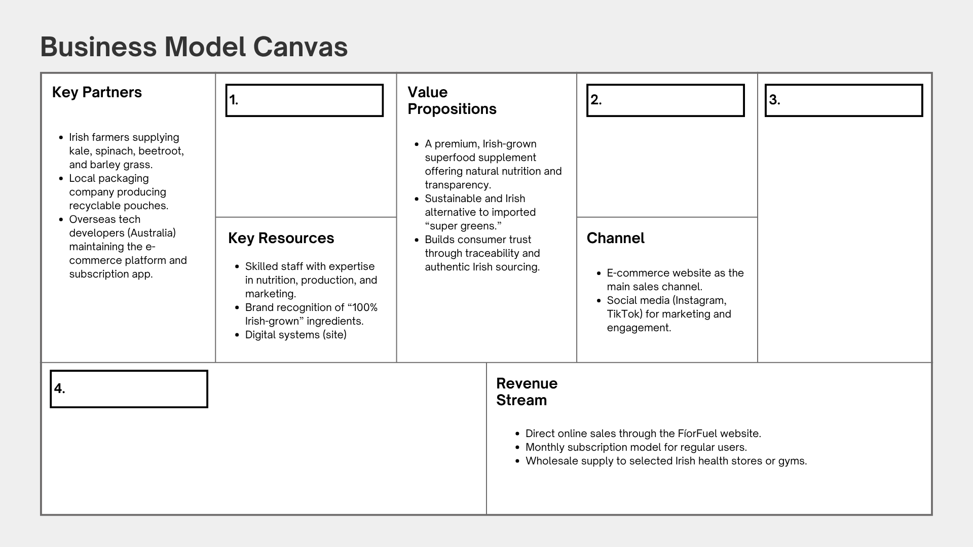
(e) FíorFuel has recently decided to expand its production capacity by leasing a new facility outside Galway to meet growing demand. The move will allow them to increase output and reduce delivery times, but it also means hiring new staff and investing in automated blending equipment.
The expansion will require temporary disruption to current operations while machinery is installed. It will also involve renegotiating supply agreements with local farmers and seeking additional funding from investors to support the move. The company plans to begin production in the new facility within six months.

(i) Conduct stakeholder mapping to identify and prioritise four stakeholders affected by this decision.

(e) (ii) Explain the importance of prioritising different stakeholder interests when making decisions in a business.

Question 2

(a) “A business owner and investor may have different priorities in how the business operates”
(i) Discuss one conflict that might arise between these two stakeholders

(ii) Suggest how a business owner could try to avoid conflict with an investor.

(b) (i) Identify three reasons why someone might decide to start their own business.
1.
2.
3.

(b) (ii) Outline the importance of enterprise for the government/economy, society and business.
Government/Economy
Society
Business

(c) Outline the importance of a business plan at both the start-up and operations stage of business development.
Start-up:
Operations:

(d) Discuss three ways the Irish Government can support businesses operating in Ireland.
1.
2.
3.

Nike's business model is built on product innovation, strong brand marketing, and a global supply chain where manufacturing is largely outsourced. The company generates revenue through wholesale, its own retail stores, e-commerce, and licensing, with a focus on creating demand through celebrity endorsements and strategic partnerships. Nike primarily sells footwear and apparel, leveraging both its strong online presence and its physical stores to reach customers globally.
(e) What is the role of a business model in a successful business.
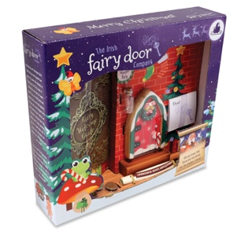
Question 3
Four friends decided to make a go of The Irish Fairy Door Company but soon realised their idea to build a magical world for children behind fairy doors would need more capital than they could provide. The Irish Fairy Door Company reached out for support from their South Dublin Local Enterprise Office, and were able to make their business a success.

(a) Identify three key competencies entrepreneurs would use when setting up a business, and for each one, outline its importance when starting or expanding a business.
1.
2.
3.

(b) Discuss three services The Irish Fairy Door Company would have been able to access from their Local Enterprise Office to support their business development and growth.

1.
2.
3.

(c) Explain three functions of a feasibility study when developing a new business idea for a business like The Irish Fairy Door Company.
1.
2.
3.

(d) If a business like The Irish Fairy Door Company was facing conflict with one of its stakeholders, outline three methods they could use to resolve the conflict.
1.
2.
3.

Question 4
(a) Arrange the stages below in the correct order and outline, using each stage, how a business of your choice could use the design thinking process to help develop/improve a product or service.
Stages: Implement, Clarify, Develop, Ideate
Business of my choice:
1.
2.
3.
4.

(b) YouTube Advertising Revenue Hits $10.3 Billion as It Takes Growing Share of TV Market

Using any two of the headings below, compare an advertising business model such as the one discussed above with another technology-driven business model you have studied.
1. Revenue generation
2. Consumer access and cost
3. Scalability and growth
4. User engagement and retention
1.
2.

(c) Compare any two of the business models below in terms of how they generate revenue and captures and delivers value for the consumer.

Circle two business models to compare: Retail, Franchise, Manufacturing
1.
2.
(d) (i) Outline two functions of a business plan for a new start-up business.
1.
2.

(d) (i) Outline two reasons why ethics and sustainability are important when planning a new start-up business.
1.
2.

