1. Introduction (Approx 200 words) – State your questions, aims, rationale
Target | Content
- State your research question clearly using the brief’s language  - Explain the rationale –> why this topic and business were chosen/matter (show curiosity, relevance, or personal interest).  - Show ethical and marketing focus –> link explicitly to ethics (honesty, fairness, transparency) and marketing (promotion, price, process Ps…).  - Reflect on the planning process -> show awareness of how you structured your plan or refined it. (e.g. key decisions or milestones.)  - Write precisely and purposefully –> no waffle. Every sentence should set up what’s coming next / or increase understanding of your investigation for the reader. | Question: How do ethical marketing practices such as honesty, fairness and transparency influence the success of Sean Casey Fitness in Ireland?  I chose to focus on the fitness industry because marketing in this area often includes exaggerated transformation claims, promises or guaranteed results and edited “before-and-after” photos. These raise ethical questions about honesty and consumer trust around typical industry marketing. After researching several Irish personal trainers online, Sean Casey Fitness stood out for its “no-nonsense,” evidence-based approach. I want to explore how genuinely ethical and transparent their marketing actually is, how consumers respond to honest versus exaggerated marketing, and whether a business in this sector can remain competitive while staying fully ethical.  To examine this, I plan to explore:  Aim 1 – What the business does: Investigate Sean Casey Fitness’ marketing and messaging across its social-media platforms, website, and Glean app.  Aim 2 – How stakeholders respond: Explore how consumers and the wider industry respond to ethical marketing, including any relevant Irish regulations or discussions about fairness and transparency in advertising.  I had initially hoped to interview the business owner for direct quotes but could not arrange this. Anticipating this challenge, I adapted by analysing Sean Casey’s podcasts to gather direct evidence of his approach to ethical marketing.

2. Investigation and Findings (Approx 400 words)
Target | Content
- Use a wide range of reliable, justified sources potentially 1–2 primary, 4–6 secondary.  - Explain why each source was chosen and evaluate its value – what does it add to your investigation.  - Present key findings clearly/visually (up to 10 allowed) tables, charts, or quote box/ infographic  - Consider different perspectives or viewpoints – include contrasting opinions or insights from stakeholders, data sources, or arguments in the media.  - Identify limitations in data or method used (gaps, bias, weaknesses…) | Aim 1 – To investigate how Sean Casey Fitness communicates its values and uses ethical marketing practices  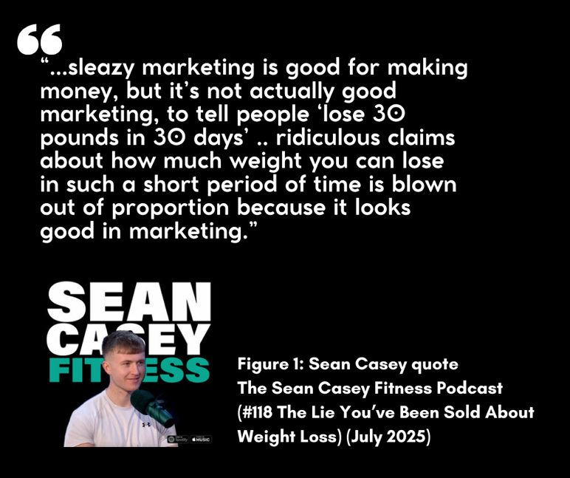  In Podcast #118 – “The Lie You’ve Been Sold About Weight Loss” (July 2025), Sean Casey rejects “sleazy marketing” and exaggerated promises such as “lose 30 pounds in 30 days.” He argues that short-term hype damages trust, preferring honesty and sustainable progress (figure 1). This first-hand source was valuable for understanding his ethical reasoning but limited by its self-produced nature.  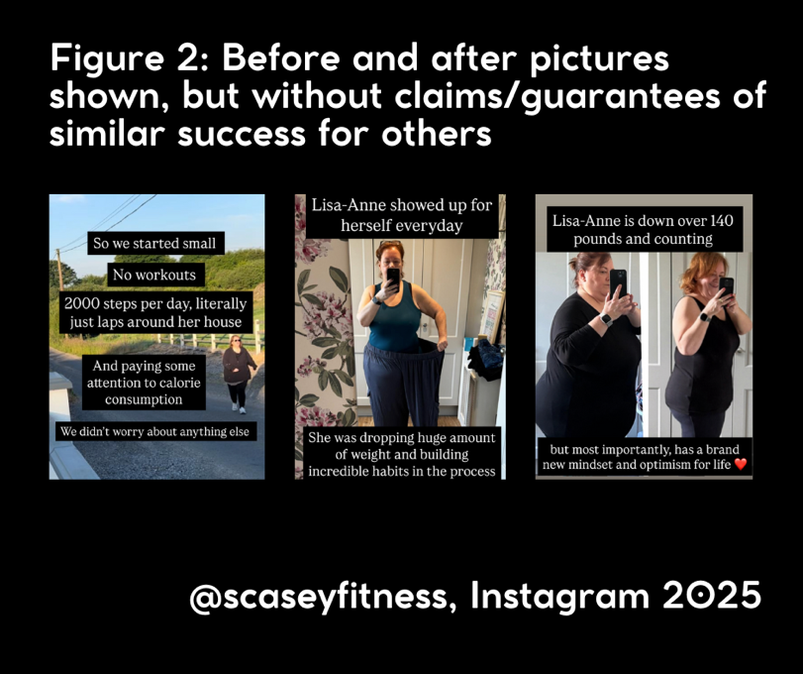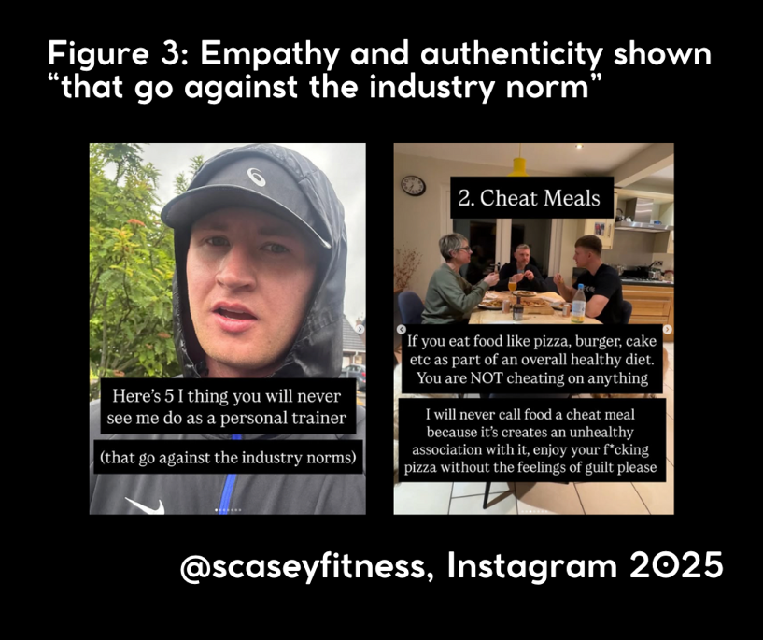  On Instagram @scaseyfitness, before-and-after photos appear intended to inspire rather than promise results, reflecting ethical use of typical industry visuals (Figure 2). However, as these show dramatic transformations, some customers might feel such outcomes are likely if they pay for his services. Across the account, posts promote empathy and avoid guilt-based language, for example rejecting the idea of “cheat meals” (Figure 3).  An Irish News article (Dec 2023) supported this view, contrasting Casey’s straightforward style with competitors who “overcomplicate fitness to profit from confusion,” adding external validation.  A Reddit thread (May 2025) offered a contrasting perspective: one user felt the £25 monthly fee for his Glean App offered little value beyond free online content. These comments appeared isolated but highlight that perceptions of fairness can challenge even ethical brands.  [213 words to here]  Aim 2 – How stakeholders respond: Explore how consumers and the wider industry respond to ethical marketing, including any relevant Irish regulations or discussions about fairness and transparency in advertising.

3. Analysis and Evaluation (Approx 600 words) – MAKE SENSE OF THE EVIDENCE
Target | Content
- Analyse and interpret findings –> identify key patterns or relationships showing how ethics influence marketing.  - Synthesise sources –> bring evidence together instead of listing it; link stakeholder viewpoints to reveal insights.  - Evaluate evidence –> judge reliability, bias, and value; note which sources are strongest and why.  - Show balance and judgement –> include opposing perspectives and explain differing views fairly.  - Link to real-world marketing –> explain what your findings mean for business practice, customer trust, or brand reputation – how can a business use this info? | Body

4. Conclusions (Approx 300 words) -> STATE WHAT YOU HAVE LEARNED
Target | Content
- Draw clear conclusions – directly answer your research question using evidence from your analysis.  - Support every point – link each conclusion to specific data, quotes, or visuals from your findings.  - Show overall insight – summarise what your investigation reveals about how ethics impact marketing.  - Make practical recommendations – suggest realistic actions a business could take based on your evidence.  - Acknowledge limitations and implications – note any gaps in your research and explain how these might affect your conclusions or future business practice. | Body

5. References
Body | Body
Body | Body

