Chapter 8 Class Exam

Name: Score:

Answer all questions
Suggested Exam Length: 40 minutes

Student Input (Pre-exam)
How confident are you about this exam? 
What topic am I worried about before I look at the exam? Why?

What strategies did you use to study for this exam? What was the best one?

Which activities in class did you most enjoy for this topic?

Student Reflection (Post-exam)
How happy were you with your result?
What were the hardest questions? Why?

Is there any exam technique I should change/use again for my next exam?

What topics should I look over again?

(a) Outline three key functions of a business plan for a new business start-up.

1.
2.
3.

(b) (i) Explain what is meant by a business model, and give an example of one for a business of your choice

(ii) Describe the role of a business model within the business plan.
(c) Identify the five key elements missing in the business model canvas given below
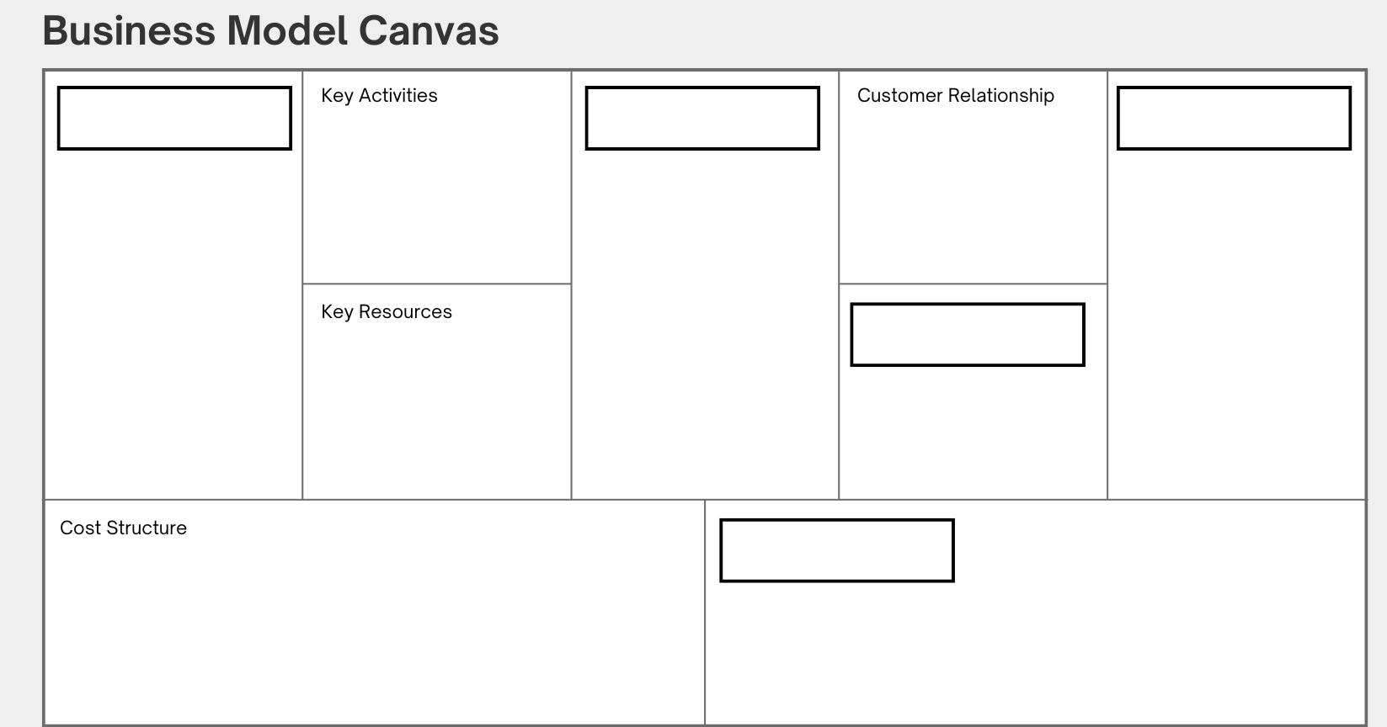
(d) Supermacs is one of Ireland’s leading franchise with stores all over Ireland.
Compare a franchise against either a retail or manufacturing business model under the headings ‘revenue generation’ and ‘How they create and deliver value’.
Revenue Generation
How they create and deliver value to customers
(e) Outline how digital technology is a driver of change in the way business’s approach their business operations.
1.
2.
3.


(f) Vinted began in Lithuania in 2008 when the founder wanted to help his girlfriend declutter her wardrobe by creating a website to sell clothes.
What started as a local project grew into a global marketplace for second-hand fashion. By mid-2024, it operated in 21 countries with over 65 million registered users
The platform connects users to buy and sell directly, without holding stock, and earns revenue from buyer fees and promoted listings.
Its growth has been driven by the rise in sustainable shopping and the ease of using the app.

Using any two of the headings below, compare a marketplace such as the one discussed above with another technology-driven business model you have studied.
Revenue generation; Consumer access and cost; Scalability and growth; User engagement and retention

1.
2.

Chapter 8 Marking Scheme – Total 61 marks

(a) 12m – 3 @ 4m (2+2)

1. To attract investment / access finance
A business plan provides lenders or investors with financial evidence that the business is viable and worth supporting.
The Financial Plan outlines projected revenue, costs and cash flow, and the Market Analysis shows the opportunity in the market.

2. To set objectives and strategies to achieve and benchmark against
It helps set clear goals and maps out how the business will achieve them, allowing performance to be measured.
The Sales and Marketing section details how the business will attract and retain customers, while the Business Model Canvas outlines how the business will operate and deliver value.

3. To assess market potential
A business plan examines whether there is demand for the product or service and if the business can compete effectively.
The Market Analysis identifies target customers, trends and competitors, while the Sales and Marketing section explains how the business will meet demand.

4. To identify potential risks and challenges
It helps spot issues like financial limits, staffing shortages or competition, and outlines how these can be addressed.
The Market Analysis shows external threats, the Financial Plan highlights funding gaps, and the Operational Plan shows limits in supply or production capacity.

(b) 8m (i) 4m (2+2) (ii) 4m (2+2)

(i) A business model explains how a company creates, delivers, and captures value. It shows how a business will earn income and serve customers.
Eg Vinted uses a marketplace business model, connecting people to buy and sell second-hand clothes directly. It earns revenue from buyer fees and promoted listings.

(ii) The business model outlines the core idea of how the business will operate, make money, and serve its target market.
It helps investors and stakeholders understand how value will be created and sustained.

(c) 5 @ 1 mark each

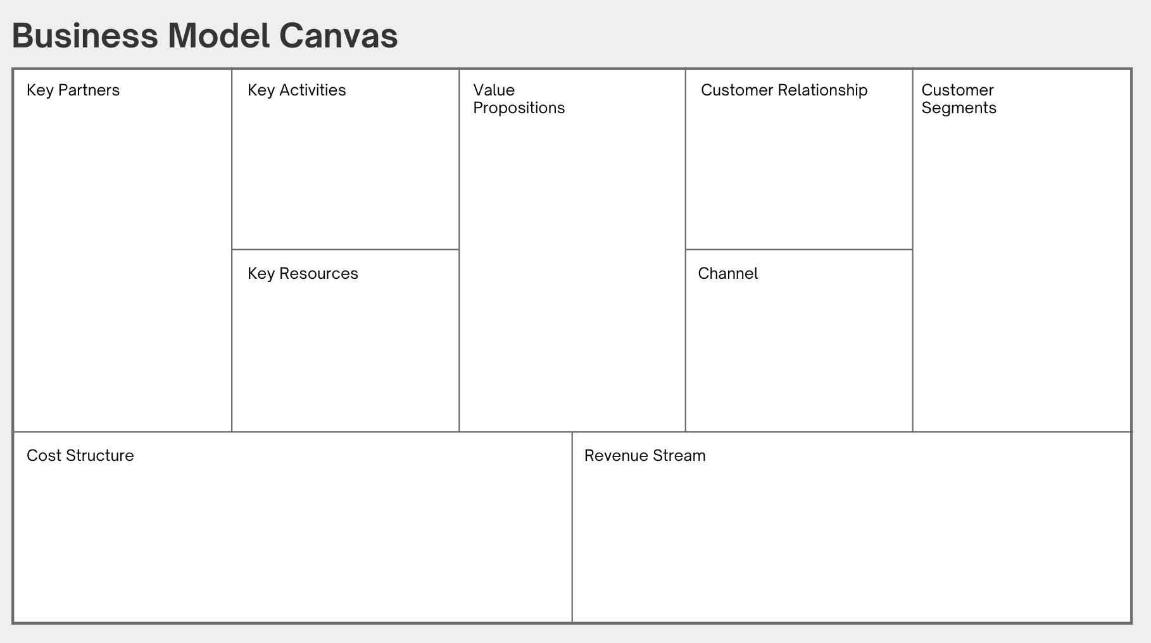

(d) 8m - 2 @ 4m (1/2+1/2) for each

Revenue Generation
A franchise generates income by charging franchisees fees to use the brand name, systems and support. This includes initial set-up fees and ongoing royalties based on turnover.
A retail business earns revenue by directly selling products to customers, either in-store or online, and relies heavily on consistent sales volume and pricing strategies to remain profitable.

How they create and deliver value to customers
A franchise delivers value through strong brand recognition, consistent product or service quality, and proven business operations. Franchisees receive training and marketing support to maintain standards across locations.
A retailer focuses on delivering value by offering a wide range of products, convenient store locations or online access, and personalised customer service to meet changing consumer needs.

(e) 12m – 3 @ 4m (2+2)
- Online Sales and E-commerce
Digital platforms allow businesses to trade 24/7, opening up access to global markets and creating new revenue streams. This shift supports innovation in logistics, product delivery, and customer service models.

- Automation and Efficiency
Digital tools such as inventory systems, CRMs, and AI reduce manual tasks and human error. Businesses like 360 Cycles and doddl use these tools to streamline communication, automate bookings, and manage customer relationships.

- Data-Driven Decision Making
Businesses use analytics to interpret consumer behaviour, measure performance, and plan ahead. Platforms like Shopify, Klaviyo, and Google guide product development and improve marketing.

- Team Communication and Operations
Apps like Slack, Trello, and Notion are central to internal collaboration. These tools help remote teams coordinate projects, plan content, and stay efficient as the business scales.

(f) 16m – 2 @ 8m (4 (2+2) x 2)

1. Revenue Generation
A marketplace model like Vinted earns revenue by charging buyer protection fees and offering promoted listings to sellers.
It benefits from high user volume and low operational costs since it does not hold inventory or manage fulfilment.
In contrast, a subscription model such as Spotify earns through regular monthly or annual payments from users in exchange for ongoing access to digital content or services.
This creates predictable income but requires the platform to retain users through content quality and personalisation.

2. Consumer Access and Cost
Marketplace models are usually free to access and use, allowing anyone to list or buy items with minimal barriers. This low entry cost encourages high user participation, supporting rapid growth and community-driven content.
In a subscription model, users must pay upfront to access full features, which may limit initial uptake but ensures committed, paying customers.
Spotify, for example, offers free trials or a freemium version to encourage users to eventually convert to paid plans.

3. Scalability and Growth
Marketplace models like Vinted scale easily because they don’t need to produce goods or manage stock. As more users join, the platform becomes more valuable through network effects, more buyers attract more sellers, and vice versa.
Growth is also cost-efficient, as the platform mainly provides digital infrastructure and support.
Subscription models like Spotify are also highly scalable, especially for digital content. Once created, the content can be delivered to millions of users at little extra cost.
However, growth depends on keeping users engaged long-term to reduce churn and maintain recurring revenue.

4. User Engagement and Retention
Marketplaces encourage engagement through community interaction, user reviews, and fresh listings. Users are retained by ease of use, low costs, and sustainable shopping trends.
Vinted adds value by offering secure payments, shipping options and seller tools, making users more likely to return.
Subscription models retain users by offering personalised experiences, exclusive features and regular updates.
Spotify, for example, uses AI to recommend music and create tailored playlists, which increases daily usage and long-term loyalty.

