Chapter 1 Class Exam

Name: Score:

Answer all questions
Suggested Exam Length: 40 minutes

Student Input (Pre-exam)
How confident are you about this exam? 
What topic am I worried about before I look at the exam? Why?

What strategies did you use to study for this exam? What was the best one?

Which activities in class did you most enjoy for this topic?

Student Reflection (Post-exam)
How happy were you with your result?
What were the hardest questions? Why?

Is there any exam technique I should change/use again for my next exam?

What topics should I look over again?

John runs Greener Cleaner Co, a start-up that produces eco-friendly cleaning products for homes and small businesses. He aims to reduce chemical waste while offering effective, plant-based alternatives.

When trying to grow, John secured investment from a private investor from his local area to purchase equipment and launch his eco-cleaning brand.
Based on his investors suggestion, he also accessed support from his Local Enterprise Office (LEO), including mentoring and grants, helped him refine his business plan and understand local market needs.

(a) Demonstrate the importance of John’s relationships with his investors and the government.
Investors
Government

(b) Outline how the needs and wants of John’s investor may change at different stages of business development of his business.

(c) (i) Identify a potential conflict that might arise between John and his (i) consumers and (ii) employees
(i) Consumers:
(ii) Employees:

(ii) Should a conflict arise with investors over the use of profits in a business, suggest two ways of resolving the conflict between an entrepreneur and their investors.
1.
2.


(d) Nuabake, an established Irish bakery business, plans to introduce a fully automated production line to replace certain manual elements in its operations. The goal is to increase efficiency and boost overall profits over time. However, this shift may lead to changes in some staff roles and a reduction in available overtime. Nuabake has communicated the decision to its key retail partner, Lidl, which accounts for 60% of its sales, assuring them that quality and supply will not be affected. To help finance the investment, Nuabake is seeking necessary government funding to purchase the new machinery through the National Enterprise Hub.

(i) Conduct stakeholder mapping to identify and prioritise four stakeholders affected by this decision.

(ii) Explain the importance of prioritising different stakeholder interests when making decisions in a business.
1.
2.

Chapter 1 Marking Scheme – Total 60 marks

(a) 10m – 2 @ 5m (3m relationship explained + 2m make clear through reasoning/ evidence /application to John) )

Investors
John’s investor provided the capital needed to buy equipment and get his business started. This support enabled him to launch quicker and with more resources. A strong relationship with an investor can also offer valuable advice and continued backing as the business grows.

Government
Through the Local Enterprise Office (LEO), John received mentoring and grants that helped shape his business plan and market strategy. This government support provided both funding and expert advice in areas that he may not have understood well like creating a business plan or cashflow, which improved his chances of early success and growth.

(b) 4m (2+2)

(i) At the early stage, the investor may accept more risk and prioritise long-term growth, focusing on brand development and market entry.
Later, as the business becomes more stable, they may want to see consistent profits and seek a return through dividends or expansion opportunities.
Their focus may shifts from potential for growth to performance (through returns) over time.

(c) (i) 2 @ 4m (2+2) (ii) 2 @ 5m (2m method, 2m solution, 1m how the solution would work)

(i) Consumers:
Consumers may want lower prices or good value for money, but using high-quality, eco-friendly ingredients could make John’s products more expensive, leading to tension over pricing.

Employees:
Employees might want predictable/set hours or job security, but as a small start-up, John may need flexibility or might not be able to offer full-time roles right away if he doesn’t know how much demand he has or how consistent demand will be.
(ii)
1. Negotiation
Negotiation involves the entrepreneur and investor discussing their views and trying to reach a mutually acceptable solution through compromise and bargaining. It helps both sides understand priorities and find a balance.
For example, John could propose reinvesting a portion of profits to grow the business while offering a small dividend to satisfy the investor’s return expectations.

2. Mediation
Mediation uses a neutral third party to help resolve the disagreement without taking sides. The mediator encourages open dialogue and helps both parties work towards a solution they agree on themselves.
In John’s case, if tensions rise over profit use, a LEO mentor or other unbiased 3rd party could act as mediator to help John and the investor agree on a profit-sharing or reinvestment strategy.

(d) (i) 20 marks (1m per quadrant labelled correctly, 0/1/2m for interest, 0/1/2m for power for each stakeholder depending on appropriate placement/justification of placement)

1. Employees – Low Power, High Interest → Keep Informed
High Interest: Employees are directly affected by reduced overtime and role changes.
Low Power: They have limited power to influence strategic decisions but care deeply about job conditions and stability.

2. Lidl (Major Retail Partner) – High Power, High Interest → Manage Closely
High Power: Lidl accounts for 60% of Nuabake’s sales, giving it strong influence over business success.
High Interest: They rely on consistent quality and supply to meet their customer expectations.

3. Government (National Enterprise Hub) – High Power, Low Interest → Keep Satisfied
High Power: The government can provide essential funding to support automation, giving them a strong influence on the project’s viability.
Low Interest: They are not concerned with day-to-day operations unless the project fails to meet funding terms, once they are satisfied the funding is used appropriately.

4. Consumers – Low Power, Low Interest → Monitor
Low Interest: As long as product quality stays consistent, consumers are unlikely to be concerned about internal production changes.
Low Power: They have little ability to influence how Nuabake manages its production decisions.

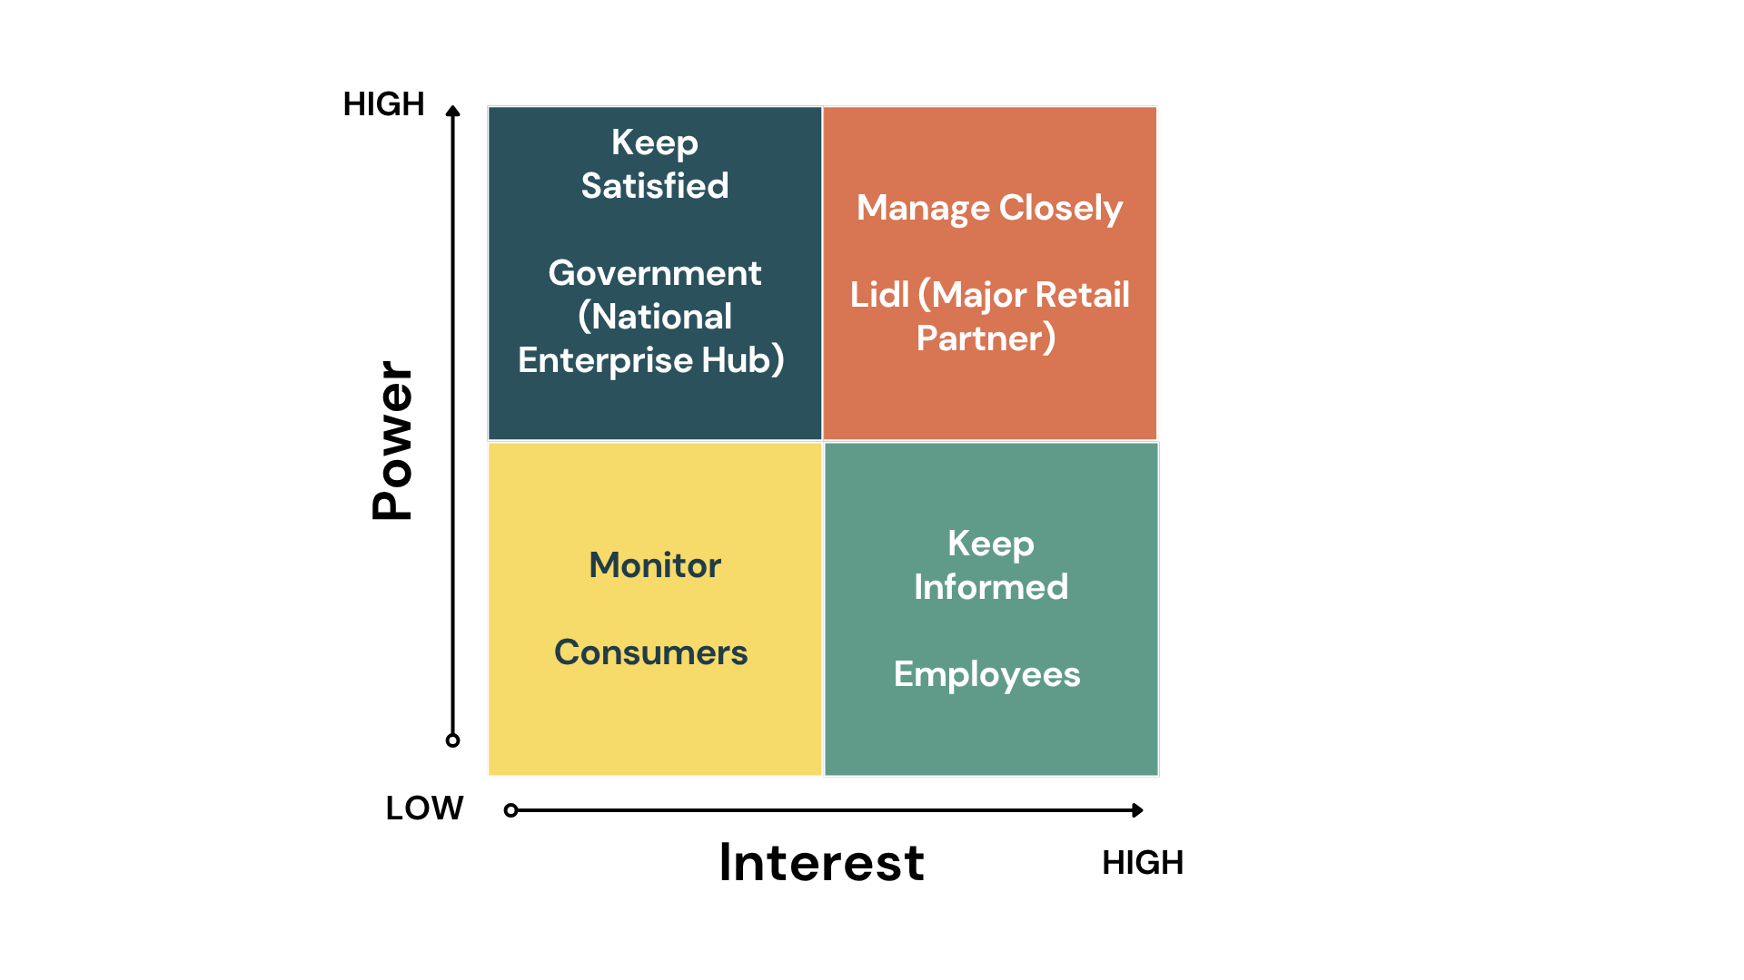
(d) (ii) 8m; 2 @ 4m (2+2)

1. Helps businesses allocate resources effectively
Using the Power–Interest Grid allows a business to focus its time, staff and communication on the most important stakeholders. Those with high interest or high power will be informed or managed more regularly, which is a more efficient use of resources than treating all stakeholders the same.

2. Supports stronger relationships and reduces future conflict
By identifying who to manage closely or keep satisfied, the business can build stronger relationships with key stakeholders. If their needs are addressed early, it lowers the chances of problems or pushback during the decision process.

Other: Improves decision-making
Knowing who to involve more heavily in decisions helps the business make clearer, more informed decisions that consider the views of the most relevant stakeholders….

